**DAILY ONLINE ACTIVITIES SUMMARY**

|  |  |  |  |  |  |  |  |  |
| --- | --- | --- | --- | --- | --- | --- | --- | --- |
| **Date:** | **29/05/2020** | | | | | **Name:** | **NAIPUNYA VINOD NAIK** | |
| **Sem & Sec** | **IV SEM & A SECTION** | | | | | **USN:** | **4AL18CS050** | |
| **Online Test Summary** | | | | | | | | |
| **Subject** | | **OPERATING SYSTEMS** | | | | | | |
| **Max. Marks** | | **30** | | **Score** | | | **29** | |
| **Certification Course Summary** | | | | | | | | |
| **Course** | **INTRODUCTION TO CLOUD COMPUTING** | | | | | | | |
| **Certificate Provider** | | | **Coginitive.ai with IBM** | | **Duration** | | | **6 HRS** |
| **Coding Challenges** | | | | | | | | |
| **Problem Statement:- 1)** [Write a Java program to Find size of the largest ‘+’ formed by all ones in a binary matrix](https://github.com/orgs/alvas-education-foundation/teams/2nd-year/discussions/86).  2) [Write a C Program to generate first N Armstrong Numbers](https://github.com/orgs/alvas-education-foundation/teams/2nd-year/discussions/87) | | | | | | | | |
| **Status: EXECUTED** | | | | | | | | |
| **Uploaded the report in Github** | | | | | **YES** | | | |
| **If yes Repository name** | | | | | <https://github.com/naipunya-naik/lockdown-coding/blob/master/C%20CODING/Armstrong_29-05-2020.c>  <https://github.com/naipunya-naik/lockdown-coding/blob/master/JAVA%20CODING/matrix_29-05-2020.java> | | | |
| **Uploaded the report in slack** | | | | | **YES** | | | |

Online Test Details: (Attach the snapshot and briefly write the report for the same).

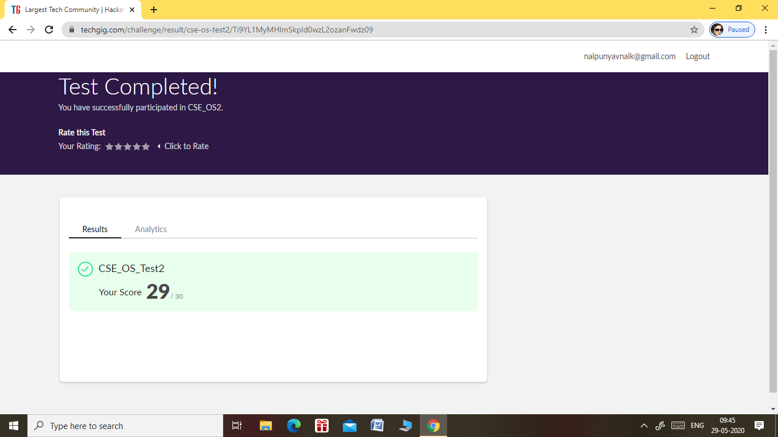

* THE 2ND I.A TEST OF OPERATING SYSTEMS WAS CONDUCTED ON 29 MAY 2020.
* SUBJECT:- OPERATING SYSTEMS
* SYLLABUS:- MODULE 2
* START TIME:- 9.00 AM
* END TIME:- 9.45 AM
* DURATION:- 45 MIN
* NO.OF QUESTIONS:- 30
* EACH QUESTION CARRIED 1 MARK

Certification Course Details: (Attach the snapshot and briefly write the report for the same)

CERTIFICATION COURSE NAME:- INTRODUCTION TO CLOUD COMPUTING

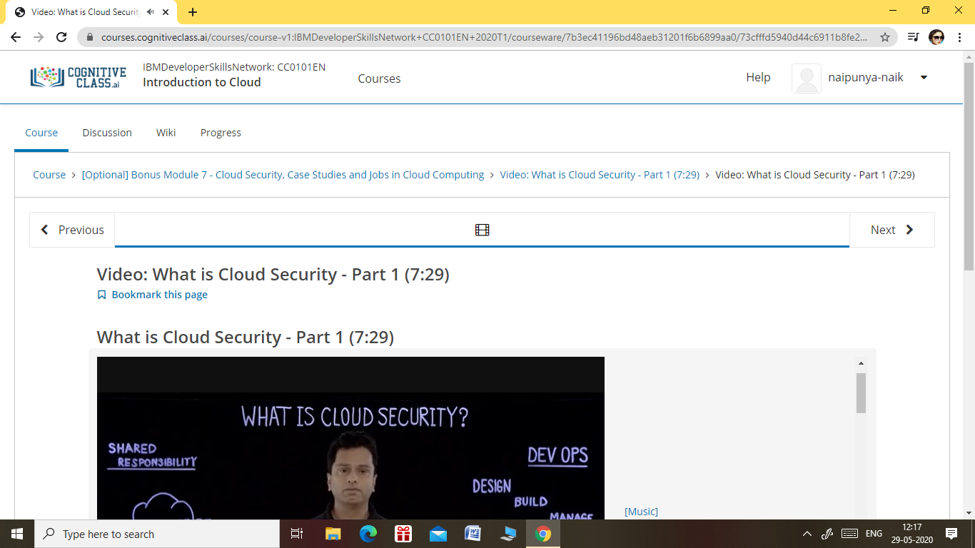

TOPICS LEARNT ON 29 MAY 2020:-

Module 7 - Cloud Security, Case Studies and Jobs in Cloud Computing (3 hrs)

* 1. Module Introduction and Objectives
  2. Video: What is Cloud Security - Part 1
  3. Video: What is Cloud Security - Part 2
  4. Video: Case Studies in Different Industry Verticals
  5. Video: Career Opportunities and Job Roles in Cloud Computing
  6. Reading: Module Summary
  7. Practice Quiz

Coding Challenges Details: (Attach the snapshot and briefly write the report for the same)

PROBLEM STATEMENT 1:- [Write a Java program to Find size of the largest ‘+’ formed by all ones in a binary matrix](https://github.com/orgs/alvas-education-foundation/teams/2nd-year/discussions/86). Given a N X N binary matrix, find the size of the largest ‘+’ formed by all 1s.For above matrix, largest ‘+’ would be formed by highlighted part of size 8.  
**Answer should be 8**.

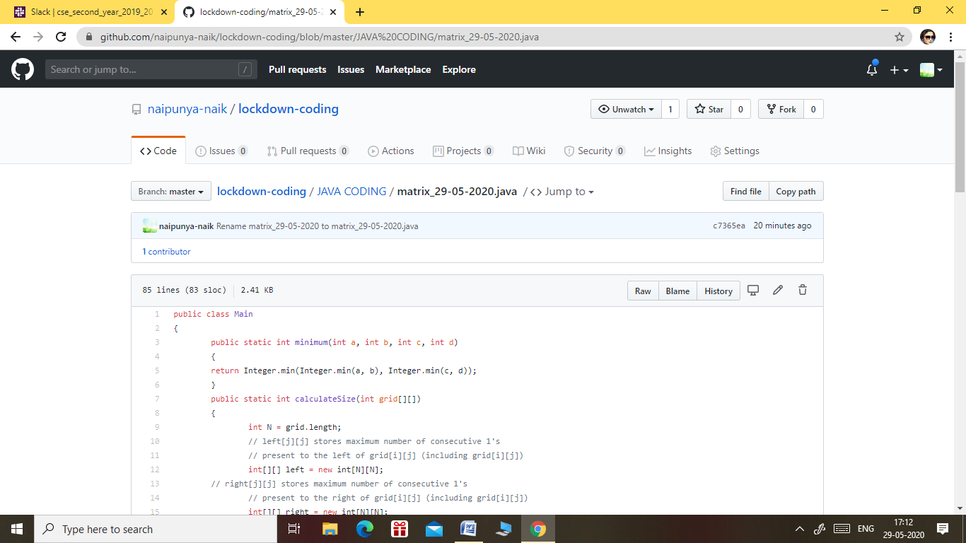

GITHUB REPOSITORY LINK:-

<https://github.com/naipunya-naik/lockdown-coding/blob/master/JAVA%20CODING/matrix_29-05-2020.java>

PROBLEM STATEMENT 2):- [Write a C Program to generate first N Armstrong Numbers](https://github.com/orgs/alvas-education-foundation/teams/2nd-year/discussions/87).

Armstrong number is a number that is equal to the sum of cubes of its digits. For example 0, 1, 153, 370, 371 and 407 are the Armstrong numbers.

Example 1:  
Let's try to understand why 153 is an Armstrong number.  
153 = (111)+(555)+(333)  
where:  
(111)=1  
(555)=125  
(333)=27  
So:  
1+125+27=153Example 2:  
371 = (333)+(777)+(111)  
where:  
(333)=27  
(777)=343  
(111)=1  
So:  
27+343+1=371

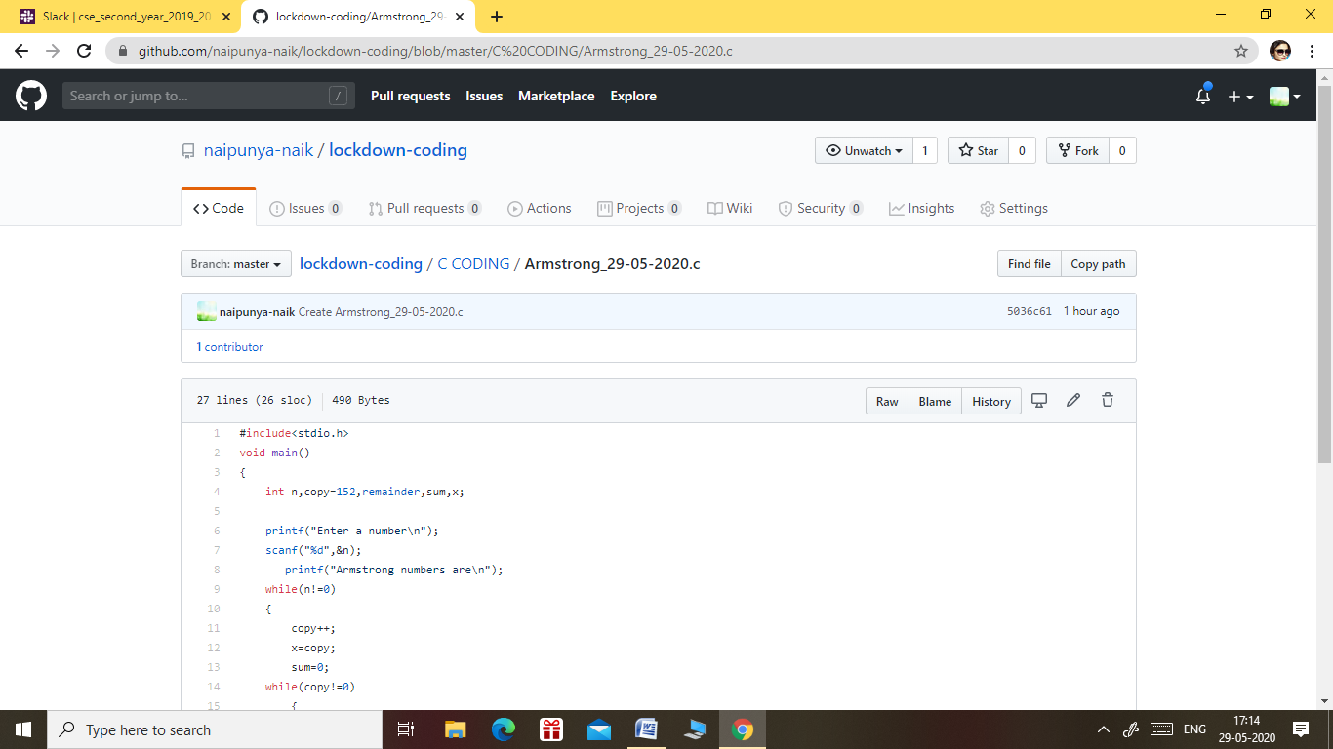

GITHUB REPOSITORY LINK:-

<https://github.com/naipunya-naik/lockdown-coding/blob/master/C%20CODING/Armstrong_29-05-2020.c>